1. Is Ex01.exe a .NET Assembly? **Yes**

2. Is Ex01.exe a .NET PE? **Yes**

Please provide a short explanation that supports your answers:

Please provide the following info about the Assembly which is contained in Ex01.exe

a. Name: **B21_Ex01**

b. Version: **21:2:1:30227**

c. In which section in the assembly you can find the answers to the previous questions (a, b)? **Manifest**

d. Which assemblies are being referenced by this assembly?

Name: **mscorlib** Version: **4:0:0:0**

Name: **System.xml** Version: **4:0:0:0**

|  |  |  |
| --- | --- | --- |
| **Type** | **Name** | **Members (methods, fields)** |
| Public Class | DemosLauncher | **Nested Classes:**   * Public class DemoPrograms * Pubilc Class eUserChoice   **Methods:**   * public void .ctor() * public static void ExecutePrograms() * private static bool checkUserCredentials() * private static eUserChoice retrieveUserSelection() * private static void showMenu() |
| Public Class | DemoPrograms | **Methods:**   * public void .ctor() * public static void RunBinarySeries() * public static void RunSandMachine() * private static bool checkIfAscendingSeries(string i_NumberStr) * private static bool checkIfDescendingSeries(string i_NumberStr) * private static void drawSandMachine(int32 i_NumOfLines) * private static int32 generateLineOfAstrix(StringBuilder i_SB, int32 i_PlaceInText, int32 i_Rows) * private static string getInputFromUser(int32& o_CrrentNumber) |
| Private Enum | eUserChoice | **Fields:**   * public static eUserChoice Abort * public static eUserChoice BinarySeries * public static eUserChoice SandClock * public int32 value__ |
| Public Class | Program | **Methods:**   * public void .ctor() * public static void Main() |

4. What is the Username and Password that should be typed in order to run the application? (a small detective task..)

**Username: DotNet**

**Password: C###**

Task One Given Examples: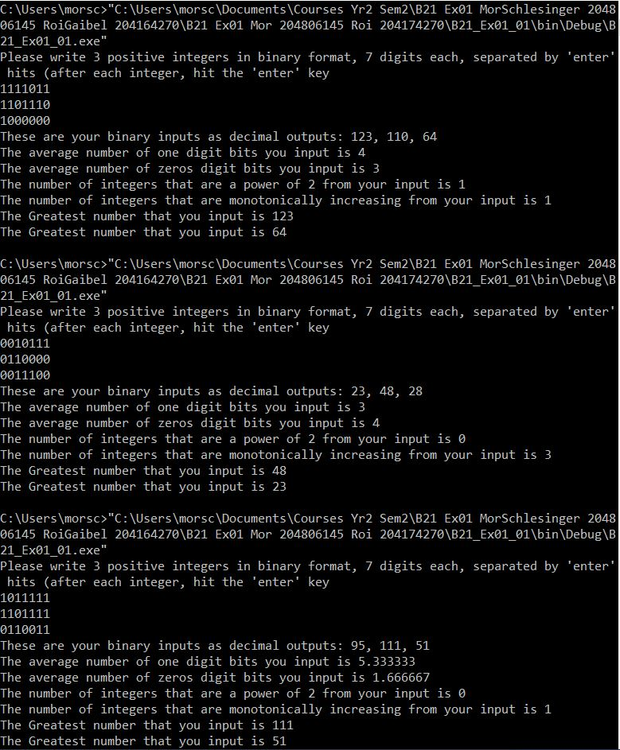

Task one our Example: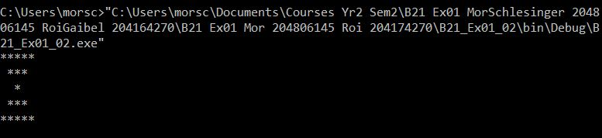

Task Two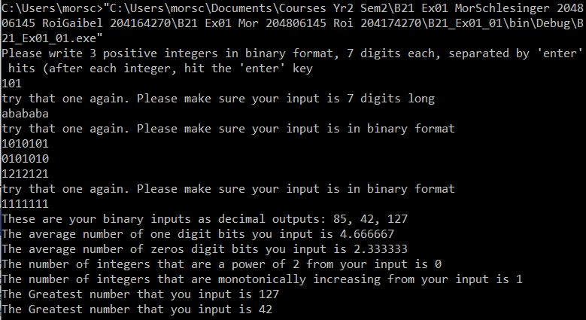

Task Three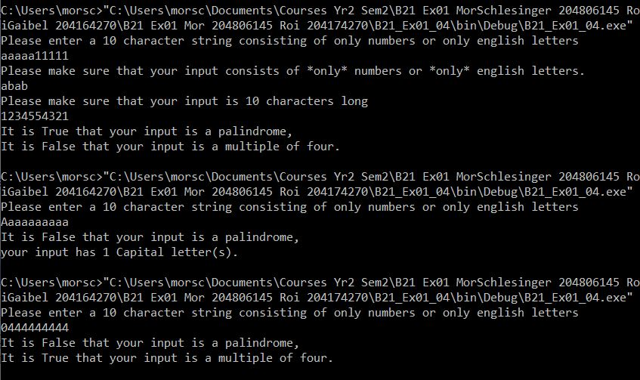

Task Four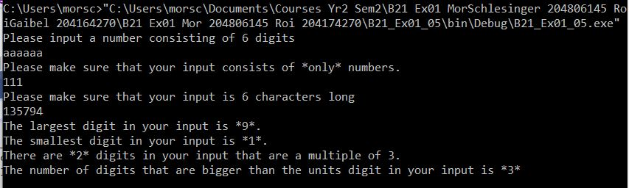

Task Five